a Stochastic Search for a Target on a Textured Background

A. D.F. Clarke, P. R. Green & M. J. Chantler

We present a comparison between human search performance and that of a stochastic model. The model uses the results of a Signal-Detection experiment to model target detectability and makes random saccades, weighted by empirically derived saccade amplitude and direction distributions. We compare the model against human performance in terms of the number of saccades required to find the target and the spatial distribution of the fixations. We find that the model compares well with human performance despite not integrating information across successive fixations or keeping track of previously fixated image regions.

# Introduction

Visual search is a common task which we encounter daily in real life. Within the confines of the laboratory, search tasks frequently involve searching within an image for a designated target item. A complete computation model of this task should contain two parts: a feature extraction mechanism and a search strategy. The feature extraction stage takes information from the stimuli and processes it to give an activation map. This process can take top-down guided search into account (Wolfe, Cave, & Fransel, 1989; Wolfe, 1994; Wolfe & Gancarz, 1997; Wolfe, 2007) along with bottom-up saliency effects (Itti & Koch, 2000; Gao, Mahadevan, & Vasconcelos, 2008; Itti & Baldi, 2008). For the sets of abstract, discrete search items commonly used as visual search stimuli, categorical features such as colour, orientation, shape and size are often used. In these cases simple qualitative comparisons between the search items and the target are often enough (Pomplun, Reingold, & Shen, 2003; Rutishauser & Koch, 2007). For more complex stimuli, such as a target hidden in image noise, or in a photograph of a natural scene , we no longer have a discrete set of items to consider and more sophisticated image processing techniques are required (Rao, Zelinsky, Hayhoe, & Ballard, 2002; Clarke, Green, & Chantler, 2009; Tavassoli, van der Linde, Bovik, & Cormack, 2009).

The search strategy part of a model uses the activation map to generate successive saccades. While a number of different mechanisms for this have been put forward, the most commonly implemented is the MAXP Observer (Najemnik & Geisler, 2005). This strategy directs saccades to the local maxima of the activation map, and a simple inhibition of return mechanism is used to stop the model returning to previously fixated maxima. As most previous computation models have primarily been interested in the feature extraction stage of search, this strategy has often been assumed for simplicity (Itti & Koch, 2000; Rao et al., 2002; Pomplun et al., 2003; Rutishauser & Koch, 2007; Clarke et al., 2009).

An alternative to the MAXP Observer is the Ideal Observer which Najemnik & Geisler (2005; 2008) have derived for a search task involving a target hidden in $1/f$-noise. Najemnik and Geisler based their model on visibility maps calculated from empirical data collected during a signal detection experiment. This visibility is used to control how much noise is added to potential target locations (with more noise at higher eccentricities) in the simulations. The Ideal Observer then makes saccades to the target location which will *maximise the likelihood of it being able to identify the target in the following saccade*. This contrasts with strategies where the model makes a saccade to the location which is currently most likely to be the target. In a second experiment observers carried out a prolonged search using similar stimuli. The results showed that over a range of task difficulties human observers take a similar number of saccades to the Ideal Observer. Furthermore, when averaged over all trials, the Ideal Observer matched the spatial distribution of fixations: both the model and human observers exhibited a preference for fixating above and below the centre of the image.

Most the above models assume that human observers implement a systematic search strategy. However human scan-paths appear to contain a large degree of randomness and apart from the easiest visual searches two human observers are unlikely to inspect the same search items in the same order. Similarly, mean reaction times from search experiments often come from distributions with high variance. Random walks have been successfully used to model an observer’s speed and accuracy in present/absent forced choice experiments (Stone, 1960; Reeves, Santhi, & DeCaro, 2005). Rather than model the spatial distribution of fixations these models simulate the observer’s decision making process. The random walk occurs between two boundaries one for a target present response and one for target absent, and is governed by a drift and bias. Motter and Holsapple (2001) demonstrated that chance plays a significant role in visual search performance as monkeys search for a T among L’s (and vice versa). Using the saccade amplitude distributions, they calculated the probability of fixating the target by chance under different conditions. While this chance component decreases as the number of distracters increase, it continues to account for a sizeable fraction of performance. A number of models ranging from completely random to systematic have been derived: however they have not been compared with human performance (Morawski, Drury, & Karwan, 1980; Arani, Karwan, & Drury, 1984; Melloy, Das, Gramopadhye, & Duckowski, 2006).

Several more general tendencies have been taken to be indicative of systematic search strategies. Gilchrist and Harvey argue that the presence of horizontal bias in saccade directions indicates a systematic component in visual search (Gilchrist & Harvey, 2006). They suggest that systematic tendencies can be hard to detect in scan-paths because of the interaction with salience-based object selection. Aks et al have argued that the presence of $1/f$ dynamics in saccade-time series is evidence of a systematic component in visual search that relies on memory of previous fixation locations (Aks, Zelinsky, & Sprott, 2002; Aks, 2005). They carried out the same time-series analysis on a random walk and found that it did not exhibit the same properties. However the details of the precise nature of the random walk and the following comparison were not included in the paper. Furthermore, it is possible that Aks’ result is an artefact of studying the compound time-series of large number of visual searches, one after another. It has been shown that a coarse-to-fine dynamic is often present in saccade patterns during search (Over, Hooge, Vlaskamp, & Erklens, 2007). If we were to look at the saccade amplitude time-series of several individual searches, each with a coarse-to-fine dynamic, then we would expect to see a strong low frequency component which could, at least partially, explain Aks et al.’s result.

Similarly, distance-to-target dynamics have been put forwards as evidence for some systematic component in visual search (Tseng & Li, 2004). These dynamics suggest that there are two phases to the search process: a ineffective stage, followed by an effective stage in which the distance from the current fixation location to the target decreases monotonically. However Greene has shown that these dynamics also arise in simple random walk simulations (Greene, 2008). These simulations generated saccades at random with a constraint on the saccade amplitudes such that they were between 20 and 50 pixels wide. The target was assumed to be detected if it was within 20 pixels of the current fixationTher, and the model was given a maximum of 15 saccades to find the target. Further support for the idea of unsystematic visual search comes from several studies which show that memory only plays a small role in visual search tasks (Horowitz & Wolfe, 1998; Horowitz & Wolfe, 2001; Kuna, Flusberg, & Wolfe, 2008; Wolfe, Klempen, & Dahlen, Postattentive Vision, 2000).

Our aim in this study is to determine whether a stochastic search strategy can account for human performance in a search task involving a target on a continuous textured background (see Figure 1 for an example). Using a continuous[[1]](#footnote-2) textured background as a distracter has a number of advantages over the more traditional task of searching for a discrete target item among distracters (Clarke, Green, Chantler, & Emrith, 2008). Firstly, these images are more naturalistic in appearance than arrays of discrete items. Secondly, unlike photographs, we can create as many different yet statistically equivalent textures, which is useful when running psychophysical experiments. A final property of these stimuli is that the difficulty of the search task is controlled by only two factors: the saliency of the target against the textured background, and its distance from the centre of the image (Clarke et al., 2009).

In our previous work we have applied an LNL-based model to the problem of modelling search for a target on a rough surface (Clarke, et al., 2009). A bank of Gabor filters was applied to the input image and then passed through a non-linearity. This nonlinear processing strengthened the signal of filter response maps containing a small number of strong local maxima (as opposed to maps which contained a large number of local maxima). Finally these feature maps were passed through a 2nd order linear filter (local energy pooling) before being summed together to give an activation map. This activation map was then passed to a simple saccade selection algorithm. For each fixation an exponential distance dependant fall-off was applied to the activation map along with a simple inhibition of return process. The model would then randomly select one of the $n$ (=3) largest local maxima as its saccade target.

While the algorithm succeeded in modelling human performance (in terms of the number of saccades required to find the target), it did not account for the selection of individual fixation points on each saccade, in trials where more than one or two saccades were required to find the target. There was no apparent relationship between human fixation locations and (non-target) local maxima in the activation map (see Figure 2 for an example). As the example shows, human observers often make long saccades that cannot be explained using our eccentricity dependant exponential fall-off. While one possibility would be that the fall-off function is too strong, we can discard this suggestion as weakening the activation fall-off function would cause the model to diverge from human performance in terms of number of saccades to targets at high eccentricities.

|  |  |
| --- | --- |
| RMS=1.1_beta=1.7_r=225_seed=45.png | SaccadePrediction.jpg |
| Figure (left): An example of a $1/f^{β}$-noise textured surface with a target (a small circular indent). Figure (right): An example activation map from the LNL search model (Clarke et al. 2009).The target can be seen near the top of the image. The current fixation location is near the bottom left corner which appears brighter than the rest of the image due to the eccentricity dependant fall-off in activation. The blue lines show the three possible saccades predicted by the model, and the red line shows the actual saccade made by the human observer. | |

To explore whether Figure 2 is typical of the model’s behaviour we compared saccade targets for the model with those chosen by human observers in the experiment reported by Clarke et al. (2009). Over all observers, trials and fixations, 22% of saccades were directed to within $1^{∘}$ of one of the three saccade targets considered by the model, and over 25% fell more than ${4.3}^{∘}$ (=a quarter of the display’s length) away from the nearest point considered by the model.

The LNL model is therefore able to predict the locations of only a small proportion of non-target fixations during visual search. Furthermore, most of the successful cases can be accounted for by chance. Let us assume:

* that all (both the model’s and human) saccades are no more than $r$ in amplitude.
* the three potential fixations considered by the model are separated from each other by at least $2^{∘}$.

Then the fixations will occur somewhere within an circle with area $A=πr^{2}$. Therefore the probability of the human saccade landing within $1^{∘}$ of one of the model’s saccades is $p=\frac{3π}{A}=\frac{3}{r^{2}}$. If we take $r=4^{∘}$ (over half of the human saccades are under $4^{∘}$ in amplitude) then we would expect human observers to fixate within $1^{∘}$ of one of the fixation locations considered by the model 19% of the time, which is close to the 22% we obtained from the empirical comparison.

The above analysis suggests that the LNL model, while offering a good prediction of the difficulty of the search task, does not succeed in modelling saccade selections any better than if it did not possess an activation map. In this study, in order to investigate search strategy only, we will assume a feature extraction mechanism and use an empirical visibility model based on based on the results of a signal detection experiment as the starting point for the search strategy. This mirrors Najemnik and Geisler’s methods (2005). However, we will use the visibility model in conjunction with a stochastic process which draws saccade amplitudes and directions from empirically derived distributions, in order to determine whether, in our task, a simple random walk model is sufficient to account for human saccade paths.

Note that there are two differences between the stimuli used by Najemnik and Geisler and ours. Firstly they used $1/f$-noise as their stimuli whereas we have combined $1/f$-noise with an illumination model to give surfaces that appear naturalistic (Clarke et al., 2008). Secondly, they only consider 85 potential target locations, whereas in Clarke et al. (2009) the target could be centred at any pixel within a given distance from the centre. While we would not expect human observers to notice this difference, the lower number does considerably simplify the derivation of the Ideal Observer. If the target is allowed to be positioned anywhere in the stimuli, then the independence assumption required by the Ideal Observer model is no longer valid.

# Experiment One – Signal Detection

The aim of this experiment is to measure the probability of target detection for different eccentricities and surface roughness combinations. This will then give us a visibility map upon which we can base a simple model for the probability of target detection at different eccentricities and surface roughnesses.

## Stimuli

A range of rough surfaces were generated by applying Lambert’s cosine law to height maps generated by a $1/f^{β}$-noise process. For full technical details see Clarke et al. (2008). The surface roughness is governed by $β∈\left\{1.60, 1.65, 1.70\right\}$ and a scaling factor, RMS roughness, which was kept constant, $σ_{RMS}=1.1$.

For the target present trials, the target was located at one of 72 potential locations: nine different eccentricities were used ${ 0.84}^{∘}≤r≤{7.5}^{∘}$, and eight evenly spaced orientations. (For an example, see ). The target was made by subtracting an ellipsoid from the three dimensional surface and subtended ${0.66}^{∘}$ of visual angle.

For each parameter combination, twenty different trials were created (by changing the random seed used to create the noise we can create different, yet statistically identical textured surfaces). Additionally, 160 target absent trials were included for each value of $β$. This gave a total of 2160 target present trials and 480 target absent. (The number of target absent trials was based on pilot results and ensured that observers made roughly equal numbers of positive and negative responses. As a large number of the target present trials were answered incorrectly we do not need so many target absent trials.)

## Method

Two participants carried out all the trials, split into twenty subgroups, over a number of days. They were paid £50 each.

Within each subgroup of 132 trials there were 33 runs of 4 trials. During each run the participants were instructed to keep their eyes fixated on the centre of the image. Each trial consisted of a fixation cross (500ms), stimulus (200ms), white noise mask (500ms), and finally a fixation cross was displayed until a target present or absent response was given.

## Results

Trials in which fixation was not held at the centre of the image (14%) were removed from further analysis. The results for the two individual participants are shown in Figure 3. For all cases, the accuracy for the target absent trials is >90%, and hence false positives will not be included in any further analysis. The directional data were very noisy and hence all further analysis will assume an isotropic visibility map.

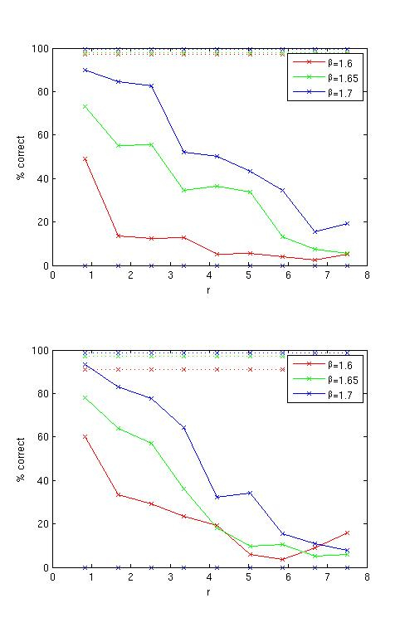

Figure : Results for the two participants

The two subjects performed similarly and the mean target present performance is shown in Figure 4. We will model this by using a simple multi-linear model:

$$p\left(T|β,r\right)= 4.09β-0.11r-5.97$$

This regression model gives $R^{2}=0.934$.

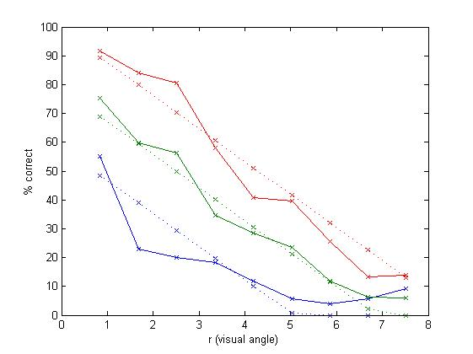

Figure : Combined results, and the multi-linear regression lines

# Simulation

The simulation used the linear-regression detection model, based on the results of the signal detection experiment, together with data on human saccade distributions taken from previous work, to construct a stochastic model of saccade paths during visual search.

## Human Saccade Distributions

In this section we will overview the first of Clarke et al.’s visual search experiments (2009). This experiment involved similar stimuli to those described above, although only 3 different target eccentricities were used. Seven observers completed the experiment and the task was simply to press a button on the keyboard once the target had been found. They were given unlimited time and an eye-tracker was used to monitor fixation locations. As the surface was made rougher (decreasing $β$ and increasing $σ_{RMS}$) a greater number of saccades were required to find the target. We will now carry out some further analysis of this data set.

The global saccade amplitude and direction distributions are shown in 5. As we can see, the saccade directions show the same horizontal bias as reported by Gilchrist & Harvey (2006) and Najemnik & Geisler (2008). The saccade amplitude time series (see Figure 6) shows evidence for a coarse-to-fine search strategy, as reported by Over et al. (2007). Figure 7 shows the relationship between saccade direction and amplitude: there is no clear relationship between them, and so we will treat the two distributions as independent. Najemnik & Geisler (2008) reported that the two observers in their experiments exhibited a preference for making fixations above and below the central fixation cross. As we can see in Figure 8 this preference does not show up in the data collected from our seven participants.

|  |  |
| --- | --- |
| SaccadeAmplitudesAndDirections.jpg | FixNumber_avgSaccAmp.jpg |
| Figure (left): Saccade Amplitude Histogram and Directional Rose Plot. Figure (right): The saccade amplitude time series. | |

|  |  |
| --- | --- |
| ampdirdepend.jpg | globalhumanhotspotmap.jpg |
| Figure (left): Hotspot map showing the relationship between saccade directions and amplitudes. The $x$-axis shows saccade direction (from $0^{∘}-{360}^{∘}$) while the $y$-axis gives saccade amplitude. The distribution of saccade for each direction (in $1^{∘}$ bins) has been normalized to give us a better picture of the dependence between the two variables. Figure (right): Overall hotspot map for our experimental task. | |

## Algorithm

### Inputs

The model is given $N$ the size of the search area $N$, $β$ the roughness of the surface $β$, and the target location (chosen randomly for a given eccentricity $r$). The initial fixation is set to the centre of the search area.

### Target Detection

On each fixation the probability that the model detects the target is given by $p=f(β,r)$ where $r$ is the distance from the current fixation to the target, $β$ governs how rough the surface is, and $f$ is the linear regression model of the results in Experiment One. For each fixation we generate a random number $x∈[0,1]$ and check to see if $x≤p$, in which case the model detects the target, makes a saccade to the target’s location, and the search is terminated. If the model does not detect the target (i.e. $x>p$) then a random saccade is made to a new location.

### Generating a Saccade

In order to generate human-like scan paths we will use the empirical distributions of saccade directions and amplitudes, obtained as described above, as probability density functions. Since the amplitude distribution varies with the position of a saccade in the sequence made during a search trial (as indicated by Figure 6), we use separate empirical distributions for each saccade number as a trial is simulated. For each saccade number $t, 1≤t≤50$ we draw an amplitude from the distribution of saccade amplitudes made by human observers on the $t$ th saccade of a search trial. If the model needs to make more than 50 saccades to find the target, it draws amplitudes from the distribution for $t=50$. The model is allowed to make a maximum of 200 fixations.

## Results

Considering first the performance of the model in terms of numbers of fixations required to find targets, we see that it performs in a similar way to the human observers in Clarke et al. (2009) (Figure 9). While it finds the target in fewer fixations than the mean human observer, when we compare the individual observers with the model in each condition we see that the model is within the range we would expect from a person.

Next, we compare how efficiently human observers and the model cover the area of the stimulus during search. If human search has systematic properties, we would expect the proportion of the stimulus area searched (i.e. falling within some criterion distance of a fixation) to increase more rapidly over the course of a human search trial than a random walk made by the model. We make this comparison by using the Voronoi method proposed by Over et al. (2006). This method allows us to study the uniformity of fixation density and involves computing the bounded Voronoi cells for a set of fixation coordinates and looking at the distribution of cell areas. If search is systematic then we would expect the fixation locations to be approximately uniformly distributed, which would give Voronoi cells with roughly equal area. If, on the other hand, search is unsystematic we would expect an uneven distribution of fixation locations and a larger range of cell areas. As our stimuli are structure-less we do not have to worry about salient regions attracting more fixations and hence generating smaller Voronoi cells. The distribution of cell areas is dependent on the number of fixations. Hence we only analyse the first 30 fixations in trials containing at least 32 fixations. This was done in order to eliminate the effect of saccades to the target. For the random walk model we generated 30 fixations, as detailed above (ignoring the target detection part of the model). Some examples of Voronoi diagrams can be seen in Figure 10, and the distributions of cell areas are shown Figure 11. As can be seen, the scan paths from the random walk give a distribution which is very similar to those seen in our seven human observers. The model’s mean cell size (10.27) lies within the range of our subjects (10.26-10.52), as does the standard deviation (model: 1.20, human range: 0.98-1.24).

Figure : Mean number of saccades required to find the target for the 7 individual observers (blue) and the stochastic search model (red).

|  |  |
| --- | --- |
| **humanVoronoiEx.jpg** | **humanVoronoiEx2.jpg** |
| **Randomwalk_Voronoicell1.jpg** | Randomwalk_Voronoicell2.jpg |
| Figure 10: Examples of Voronoi cells. Top row – two examples of fixations from searches by human observers. Bottom row – two examples of fixations made by the random model. | |

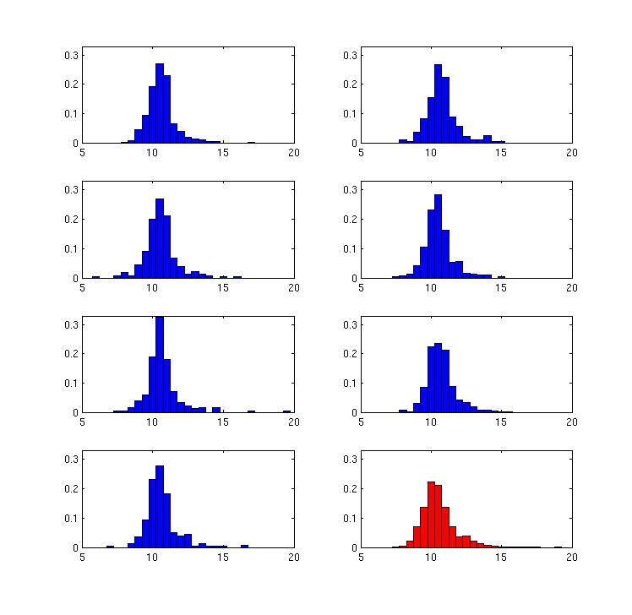

Figure : Distribution of Voronoi Cell log(areas) for the 7 individual observers (blue) and the model (red).

# General Discussion

The random walk model finds the target in a similar number of fixations as a typical human observer. Furthermore, the Voronoi method shows that model’s scan-paths are spatially distributed in a similar way as the human scan-paths. This suggests that human search behaviour can be, at least in the search task presented here, modelled using a simple data-driven stochastic process.

This is a somewhat surprising result given that Najemnik and Geisler have shown that human observers appear to be near optimal in their search strategy (2008). Najemnik and Geisler also compare the spatial distributions of the fixations chosen by their ideal observer, a MAXP model, and human subjects, and find that both human subjects and the ideal observer show a clear preference for fixation on small regions above and below the centre of the image. However, there is no evidence for this distribution in our data, which show no preferences for fixating any particular regions (see Figure 8).

One of the main arguments put forward by Najemnik and Geisler for the use of an Ideal Observer over a MAXP strategy is based on the spatial distribution of fixations that they found. The visibility map that they used had a greater horizontal than a vertical axis, and their Ideal Observer behaved in a corresponding manner: if visibility is greater along the horizontal axis then a vertical saccade will give us the most new information, and fixations will tend to fall above and below the centre of the search area. However, a MAXP type observer will tend to make more horizontal saccades, because the target is more likely to be detected at horizontal than at vertical eccentricities. Since there was no evidence in our data for the distribution of fixations that Najemnik and Geisler found, we conclude that our use of an isotropic visibility map does not account for the success of the random walk model in simulating search in our experiment.

## COnclusions

As stated above, a complete (computational) visual search model should possess two parts: a feature extraction front end and a search strategy. The aim of this paper was to explore to what extent a search strategy based on a random walk could account for human performance. Previously implemented search strategies have generally worked in a serial manner, checking items one at a time, with some form of imperfect memory (Melloy, Das, Gramopadhye, & Duckowski, 2006; Rutishauser & Koch, 2007). One search model that makes use of parallel target detection over a serial sequence of fixations is the Ideal Observer (Najemnik & Geisler, 2008). One problem with this approach is that it assumes that the target will be located at one of a predefined independent finite number of potential target locations. Unfortunately, this assumption breaks down when image processing techniques are used, as the activation at any pixel is likely to be correlated with its neighbours. Hence we have explored an alternative explanation of human search strategies: a random walk. While the use of a random walk to explain patterns of fixations is not new (Greene, 2008; Aks, Zelinsky, & Sprott, 2002; Morawski, Drury, & Karwan, 1980), our model is unlike earlier ones in being strongly based on empirical data. We find that a random walk behaves in a similar way to human observers, both in terms of the number of saccades required to find the target, and the spatial distribution of fixations.

Our results here suggest that inhibition of return; integration of information across fixations, and more general memory based processes have little or no role to play in search for an inconspicuous target on a continuously textured surface. Future testing of models of visual search should consider not only possible differences between search strategies on different types of stimuli, but also variation between observers in their strategies. It may be possible to obtain evidence for more than one model of search strategy depending on the observers tested.

# Bibliography

Aks, D. (2005). 1/f dynamic in complex visual search: Evidence for Self-Organized Criticality in human perception. In M. A. Riley, & G. C. van Orden (Eds.), *Tutorials in comtemporary nonlinear methods for the behavioral sciences* (pp. 329-359).

Aks, D. J., Zelinsky, G., & Sprott, J. C. (2002). Memory across eye-movements: 1/f dynamic in visual search. *Journal of Non-linear Dynamics in Psychology & the Life Sciences* *, 6* (1), 1-25.

Arani, T., Karwan, M. H., & Drury, C. G. (1984). A Variable-Memory Model of Visual Search. *Human Factors* *, 26* (6), 631-639.

Clarke, A. D., Green, P. R., & Chantler, M. J. (2009).

Clarke, A. D., Green, P. R., Chantler, M. J., & Emrith, K. (2008). Visual Search for a Target Against a 1/f^β Continuous Textured Background. *Vision Research* *, 48* (21), 2193-2203.

Gao, D., Mahadevan, V., & Vasconcelos, N. (2008). On the plausibility of the disciminant center-surrond hypothesis for visual saliency. *Journal of Vision* *, 8* (7), 1-18.

Gilchrist, I. D., & Harvey, M. (2006). Evidence for a systematic component within scan paths in visual search. *Visual Cognition* *, 14*, 704-715.

Greene, H. H. (2008). Distance-from-target dynamics during visual search. *Vision Research* *, 48* (23-24), 2476-2484.

Horowitz, T. S., & Wolfe, J. M. (2001). Search for multiple targets: Remember the targets, forget the search. *Perception and Psychophysics* *, 63* (2), 272-285.

Horowitz, T. S., & Wolfe, J. M. (1998). Visual Search has no Memory. *Nature* *, 357*, 575-577.

Itti, L., & Baldi, P. (2008). Bayesian suprise attracts human attention. *Vision Research* .

Itti, L., & Koch, C. (2000). A saliency-based search mechanism for overt and covert shifts of visual attention. *Vision Research* *, 40*, 1489-1506.

Kuna, M. A., Flusberg, S., & Wolfe, J. M. (2008). The role of memory and restricted context in repeated visual search. *Perception and Psychophysics* *, 70* (2), 314-328.

Melloy, B. J., Das, S., Gramopadhye, A. K., & Duckowski, A. T. (2006). A model of extended, semi-systematic visual search. *Human Factors* *, 48* (3), 540-554.

Morawski, T., Drury, C. G., & Karwan, M. H. (1980). Predicting Search Performance for Multiple Targets. *Human Factors* *, 22* (6), 707-718.

Motter, B. C., & Holsapple, J. W. (2001). Separating attention from chance in active visual search. In J. Braun, C. Koch, & J. Davis (Eds.), *Visual attention and neural circuits* (pp. 159-175). Cambridge, MA: MIT Press.

Najemnik, J., & Geisler, W. S. (2008). Eye movement statistics in humans are consistent with an optimal search strategy. *Journal of Vision* *, 8* (3), 1-14.

Najemnik, J., & Geisler, W. S. (2005). Optimal eye movement strategies in visual search . *Nature* , 387-391.

Over, E. A., Hooge, I. T., & Erkelens, C. J. (2006). A quantitative measure for the uniformity of fixation density: The Voronoi method. *Behaviour Research Methods* *, 38* (2), 251-261.

Over, E. A., Hooge, I. T., Vlaskamp, B. N., & Erklens, C. J. (2007). Coarse-to-fine eye movements strategy in visual search. *Vision Research* *, 47*, 2272-2280.

Pomplun, M. (2006). Saccadic selectivity in complex visual search displays. *Vision Research* .

Pomplun, M., Reingold, E. M., & Shen, J. (2003). Area activation: a computational model of saccadic selectivity in visual search. *Congnitive Science* *, 27*, 299-312.

Rao, P. N., Zelinsky, G. J., Hayhoe, M. M., & Ballard, D. H. (2002). Eye movements in iconic visual search. *Vision Research* *, 42*, 1447-1463.

Reeves, A., Santhi, N., & DeCaro, S. (2005). A random-ray model for speed and accuracy in perceptual experiments. *Spatial Vision* , 73-83.

Rutishauser, U., & Koch, C. (2007). Probabilistic modeling of eye movement data during conjunction search via feature-based attention. *Journal of Vision* *, 7* (6), 1-20.

Stone, M. (1960). Models for choice-reation time. *Psychometrika* , 251-260.

Tavassoli, A., van der Linde, I., Bovik, A. C., & Cormack, L. K. (2009). Eye movements selective for spatial frequency and orientation during active vision search. *Vision Research* *, 49*, 173-181.

Tseng, Y. C., & Li, C. S. (2004). Oculomotor correlates of context-guided learning in visual search. *Perception & Psychophysics* *, 66* (8), 1363-1378.

Verghese, P. (2001). Visual Search and Attention: A Signal Detection Theory Approach. *Neuron* , 523-535.

Wolfe, J. M. (1994). Guided Search 2.0: A Revised Model of Visual Search. *Psychonomic Bulletin & Review* *, 1* (2), 202-238.

Wolfe, J. M. (2007). Guided Search 4.0: Current Progress with a model of visual search. In W. Gray (Ed.), *Integrated Models of Cognitive Systems* (pp. 99-119). New York: Oxford.

Wolfe, J. M., & Gancarz, G. (1997). Guided Search 3.0. In V. Lakshminarayanan (Ed.), *Basic and Clinical Applications of Vision Science* (pp. 189-192). Dordrecht, Netherlands: Kluwer Academic.

Wolfe, J. M., Cave, K. R., & Fransel, S. L. (1989). Guided Search: An alternative to the feature integration model for visual search. *Journal of Experimental Pschology: Human Perception and Performance* *, 15* (3), 419-433.

Wolfe, J. M., Klempen, N., & Dahlen, K. (2000). Postattentive Vision. *Journal of Experimental Psychology: Human Perception and Performance* *, 26* (2), 693-716.

1. “Continuous” is used to distinguish the stimuli from those which contain discrete sets of search items. As the stimuli were displayed at a sufficiently high resolution, they could perhaps more accurately be described as “perceptually-continuous” despite being discrete at the pixel-level. [↑](#footnote-ref-2)